MCj03256380000[1]j0239195j0187505j0352620j0240325j0233965MCj03043110000[1]**C:\Users\e038278\AppData\Local\Microsoft\Windows\Temporary Internet Files\Content.IE5\UST6G136\MC900355963[1].wmf**MCj00787720000[1]

Ancient exploration... post-classical exploration….  
modern exploration… exploration today… emerging explorers

**What I LEARNED today in ALPHA:**

**What I DID today in ALPHA:**

**Unanswered Questions I still have:**

**ALPHA homework/Note home:**

**Parent Signature _______________________________________________**

**(Teacher Name), GT/Enrichment teacher, ___________ Elementary School  
Email: Phone: (210) 555-5555 Ext. 5555  
Website:**

**Content Imperatives**

**Scholarly Behaviors**

Name: ______________________________ Date:______________________

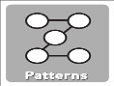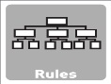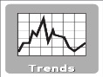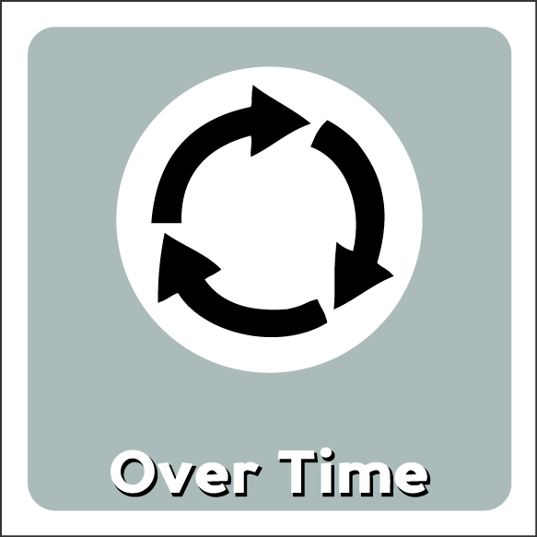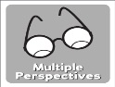

**Depth & Complexity**

Ponder Save Bring Ask good Use Multiple See from Thirst for Set Exercise  
big ideas information tools questions sources different knowledge goals intellect  
 perspectives